Glossary Part 2

2016 Science Framework
for California Public Schools
Kindergarten through Grade 12

The CA Science Framework was adopted by the California State Board of Education on November 3, 2016.
The CA Science Framework has not been edited for publication. © by the California Department of Education.

Common Next Generation Science Standards Acronyms
CCC: | Crosscutting Concept
CCSS: | Common Core State Standards
DCI: | Disciplinary Core Idea
FB: | Foundation Box
PE: | Performance Expectation
SEP: | Science and Engineering Practices
 | CCSS Connection
CC: | Counting & Cardinality
EE: | Expressions & Equations
F: | Functions
G: | Geometry
MD: | Measurement & Data
NBT: | Number & Operations in Base Ten
NF: | Number & Operations- Fractions
NS: | The Number System
OA: | Operations & Algebraic Thinking
RI: | Reading Informational Text
RL: | Reading Literature
RP: | Ratios and Proportional Relationships
RST: | Reading in Science & Technical Subjects
SL: | Speaking & Listening
SP: | Statistics & Probability
W: | Writing
WHST: | Writing in History/Social Studies,
 | Science, & Technical Subjects

2016 CA Science Framework California Department of Education

The Three Dimensions of the
Next Generation Science Standards


Dimension1: Science and Engineering Practices
The science and engineering practices describe behaviors that scientists engage in as they investigate phenomena and build models and theories about the natural world and the key set of engineering practices that engineers use as they design and build models and systems.

- Asking questions (science) and defining problems (engineering)
- Developing and using models
- Planning and carrying out investigations
- Analyzing and interpreting data
- Using mathematics and computational thinking
- Constructing explanations (science) and designing solutions (engineering)
- Engaging in argument from evidence
- Obtaining, evaluating, and communicating information

Dimension 2: Cross Cutting Concepts
Crosscutting concepts are themes that apply across all domains of science. As such, they are a way of linking the different domains of science.

- Patterns, similarity, and diversity
- Cause and effect
- Scale, proportion and quantity
- Systems and system models
- Energy and matter
- Structure and function
- Stability and change

Developed by the California Science Project based on the NRC Framework for K-12 Science Education and supporting documents from the NGSS.
Download a copy at: http://csmp.ucop.edu/csp

Dimension 3: Disciplinary Core Ideas

Physical Science | PS1: Matter and Its Interactions  PS1.A: Structure and Properties of Matter  PS1.B: Chemical Reactions  PS1.C: Nuclear Processes  PS2: Motion and Stability: Forces and Interactions  PS2.A: Forces and Motion  PS2.B: Types of Interactions  PS2.C: Stability and Instability in Physical Systems  PS3: Energy  PS3.A: Definitions of Energy  PS3.B: Conservation of Energy and Energy Transfer  PS3.C: Relationship Between Energy and Forces  PS3.D: Energy in Chemical Processes and Everyday Life  PS4: Waves and Their Applications in Technologies for Information Transfer  PS4.A: Wave Properties  PS4.B: Electromagnetic Radiation  PS4.C: Information Technologies and Instrumentation
Earth & Space Science | ESS1: Earth’s Place in the Universe  ESS1.A: The Universe and Its Stars  ESS1.B: Earth and the Solar System  ESS1.C: The History of Planet Earth  ESS2: Earth’s Systems  ESS2.A: Earth Materials and Systems  ESS2.B: Plate Tectonics and Large-Scale System Interactions  ESS2.C: The Roles of Water in Earth’s Surface Processes  ESS2.D: Weather and Climate  ESS2.E: Biogeology  ESS3: Earth and Human Activity  ESS3.A: Natural Resources  ESS3.B: Natural Hazards  ESS3.C: Human Impacts on Earth Systems  ESS3.D: Global Climate Change

Dimension 3: Disciplinary Core Ideas
(Continued)
Life Science | LS1: From Molecules to Organisms: Structures and Processes  LS1.A: Structure and Function  LS1.B: Growth and Development of Organisms  LS1.C: Organization for Matter and Energy Flow in Organisms  LS1.D: Information Processing  LS2: Ecosystems: Interactions, Energy, and Dynamics  LS2.A: Interdependent Relationships in Ecosystems  LS2.B: Cycles of Matter and Energy Transfer in Ecosystems  LS2.C: Ecosystem Dynamics, Functioning, and Resilience  LS2.D: Social Interactions and Group Behavior  LS3: Heredity: Inheritance and Variation of Traits  LS3.A: Inheritance of Traits  LS3.B: Variation of Traits  LS4: Biological Evolution: Unity and Diversity  LS4.A: Evidence of Common Ancestry and Diversity  LS4.B: Natural Selection  LS4.C: Adaptation  LS4.D: Biodiversity and Humans
Engineering, Technology, and Application of Science | ETS1: Engineering Design  ETS1.A: Defining and Delimiting an Engineering Problem  ETS1.B: Developing Possible Solutions  ETS1.C: Optimizing the Design Solution
NGSS Websites
- NGSS Official Site: http://www.nextgenscience.org
- California NGSS: http://www.cde.ca.gov/pd/ca/sc/ngssintrod.asp
- CSTA NGSS: http://www.cascience.org/csta/ngss.asp
- NSTA NGSS: www.nsta.org/ngss

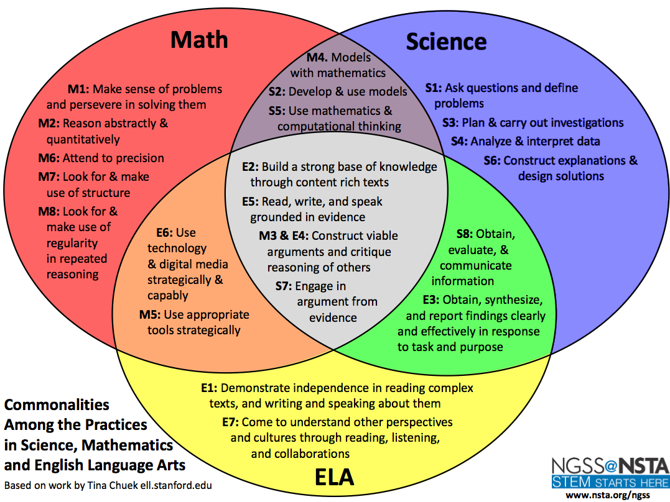

Conceptual Shifts in the NGSS

- K-12 science education should reflect the interconnected Nature of Science as it is practices and experienced in the real world
- The NGSS are student performance expectation – NOT curriculum
- The science concepts in NGSS build coherently from K-12
- The NGSS focus on deeper understanding of content as well as application of content
- Science and engineering are integrated in the NGSS from K-12
- The NGSS are designed to prepare students for college, career, and citizenship
- The NGSS and Common Core State Standards are aligned

Nature of Science in the NGSS

- Scientific investigations use a variety of methods.
- Scientific knowledge is based on empirical evidence.
- Scientific knowledge is open to revision in light of new evidence.
- Scientific models, laws, mechanisms, and theories explain natural phenomena.
- Science is a way of knowing.
- Scientific knowledge assumes an order and consistency in natural systems.
- Science is a human endeavor
- Science addresses questions about the natural and material world

